**ATLANTA POPULATION**

1.

MongoDB Enterprise atlas-5d45wr-shard-0:PRIMARY> db.zipcodes.find({city:"ATLANTA",state:"GA"}).pretty()

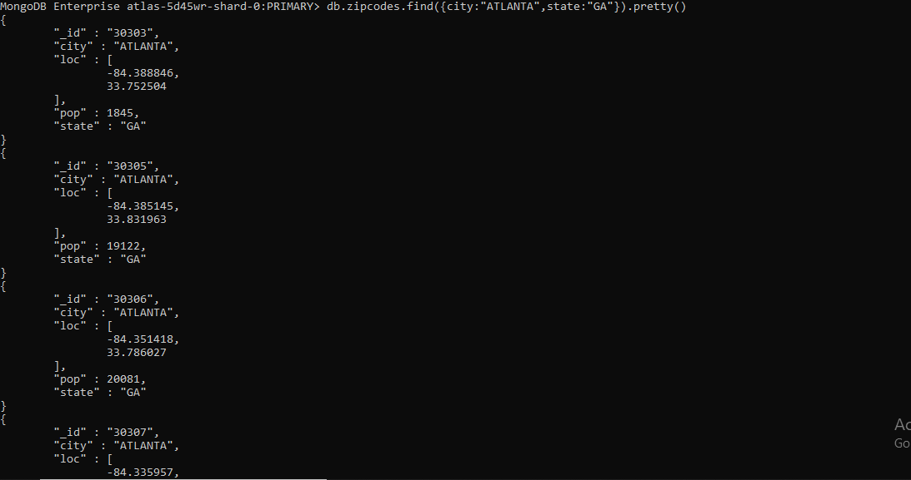

2.

MongoDB Enterprise atlas-5d45wr-shard-0:PRIMARY> db.zipcodes.aggregate([{$match:{$and:[{city:"ATLANTA"},{state:"GA"}]}}]).pretty()

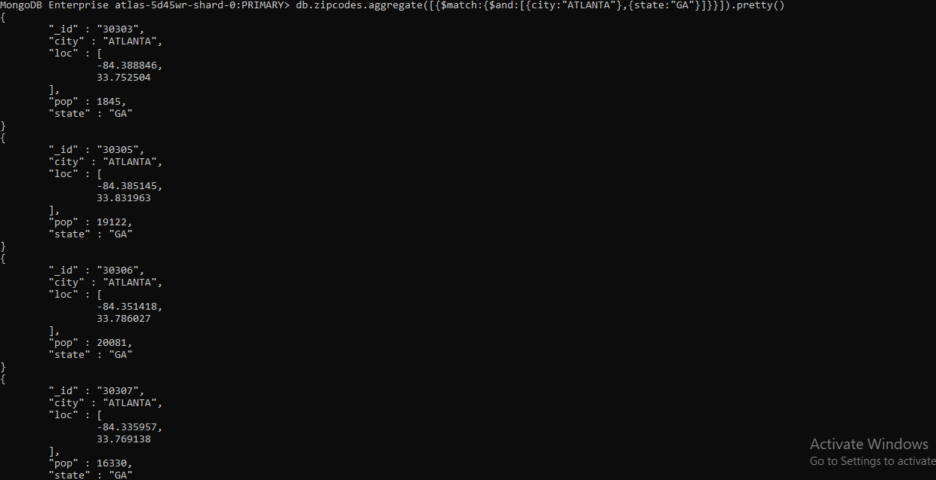

3.

MongoDB Enterprise atlas-5d45wr-shard-0:PRIMARY> db.zipcodes.aggregate([ {$match: {city:"ATLANTA"} }, {$group:{ _id:"$city", zipcodes:{$sum:1}}}])

{ "_id" : "ATLANTA", "zipcodes" : 41 }

4.

MongoDB Enterprise atlas-5d45wr-shard-0:PRIMARY> db.zipcodes.aggregate([ {$match: {city:"ATLANTA"} }, {$group:{ _id:"$city", total_pop:{$sum:"$pop"}}}])

{ "_id" : "ATLANTA", "total_pop" : 630046 }

**POPULATION BY STATE**

1.

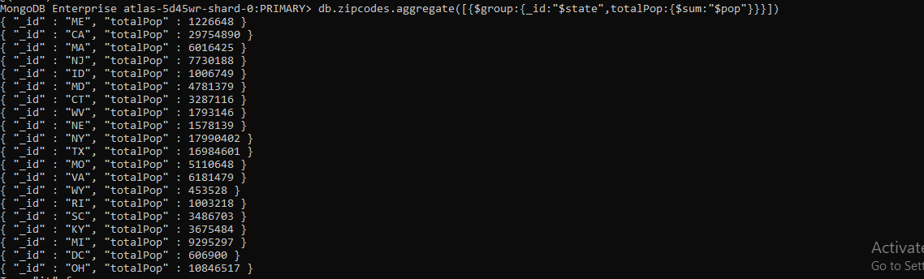

2. and 3.

MongoDB Enterprise atlas-5d45wr-shard-0:PRIMARY> db.zipcodes.aggregate([{$group:{_id:"$state",totalpop:{$sum:"$pop"}}},{$sort:{totalpop:-1}},{$limit:3}])



**Population BY CITY**

1.

MongoDB Enterprise atlas-5d45wr-shard-0:PRIMARY> db.zipcodes.aggregate([{$group:{_id:{city:"$city",state:"$state"},totalPop:{$sum:"$pop"}}}])

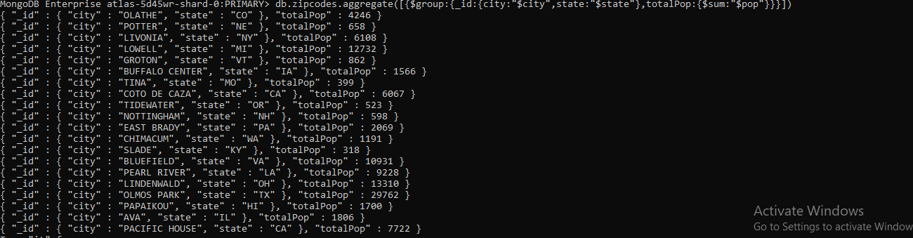

2, 3 and 4

MongoDB Enterprise atlas-5d45wr-shard-0:PRIMARY> db.zipcodes.aggregate([{$group:{_id:{state:"TX",city:"$city"},citypop:{$sum:"$pop"}}},{$sort:{totalpop:-1}},{$limit:3}]



**BONUS**

1.

|  |
| --- |
| MongoDB Enterprise atlas-5d45wr-shard-0:PRIMARY> db.zipcodes.aggregate( [ |
| ... { $group: { _id: { state: "$state", city: "$city" }, pop: { $sum: "$pop" } } }, |
| ... { $group: { _id: "$_id.state", avgCityPop: { $avg: "$pop" } } } |
| ... ] ) |

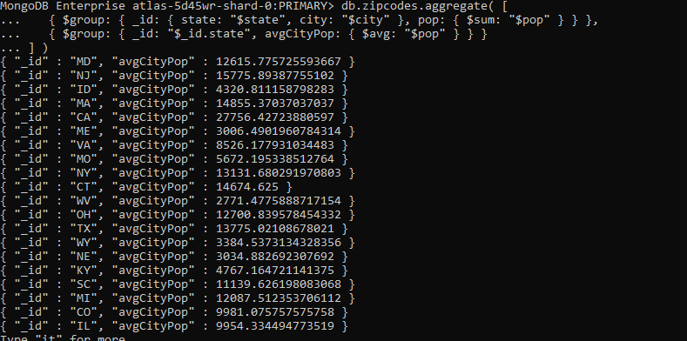

2.

MongoDB Enterprise atlas-5d45wr-shard-0:PRIMARY> db.zipcodes.aggregate( [ { $group: { _id: { state: "$state", city: "$city" }, pop: { $sum: "$pop" } } }, { $group: { _id: "$_id.state", avgCityPop: { $avg: "$pop" } }},{$limit:3} ] )

